43 .46: a) b) The nuclide is a boron nucleus, and 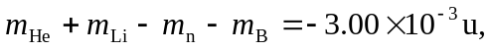 and so 2.79 MeV of energy is absorbed.

